**PSG COLLEGE OF TECHNOLOGY, COIMBATORE – 641 004**

**Department of Applied Mathematics and Computational Sciences**

**MSc SOFTWARE SYSTEMS – Semester IV**

**20XW48 – Web Designing Lab**

**PROBLEM SHEET – JavaScript Basics & Control Statements**

1. Write a JavaScript in a web page to display the current day and time.

<html>

  <body>

    <h2>DAY AND TIME</h2>

    <p id="today"></p>

  </body>

  <script>

    const date = new Date();

    document.getElementById("today").innerHTML = date.toUTCString();

  </script>

</html>

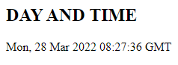

1. Write a JavaScript to convert a temperature Celsius to Fahrenheit and a temperature in Fahrenheit to Celsius.

<html>

  <body>

  </body>

  <script>

    function celsiusToFahrenheit(celsius)

    {

      fahrenheit = 9/5*celsius+32;

      output = celsius +'\xB0C is ' + fahrenheit + '\xB0F.';

      console.log(output);

    }

    function fahrenheitToCelsius(fahrenheit)

    {

      celsius = 5/9*(fahrenheit - 32);

      output = fahrenheit +'\xB0F is ' + celsius + '\xB0C.';

      console.log(output);

    }

    cel = prompt("Enter celsius to convert: ");

    fah = prompt("Enter fahrenheit to convert: ");

    celsiusToFahrenheit(cel);

    fahrenheitToCelsius(fah);

  </script>

</html>

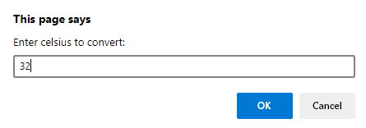 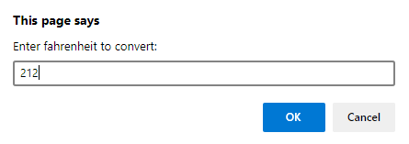



1. Write a JavaScript to compute Simple Interest and Compound Interest for a given Principal, Rate of Interest and Duration of years. Use input popup box to get the input from the user. The formula are

$Simple Interest= \frac{Principal*Years*Rate of Interest}{100}$

$Compound Interest=$*1000 $\left[{\left(1+\frac{10}{100}\right)}^{5}\right]$* – 1*

<html>

  <body>

  </body>

  <script>

    principal = prompt("Enter principal: ");

    years = prompt("Enter years: ");

    rate_of_interest = prompt("Enter rate of interest: ");

    si = principal*years*rate_of_interest / 100;

    console.log("Simple Interest: ", si);

    ci = principal * (Math.pow(1+rate_of_interest/100, years)) - principal;

    console.log("Compound Interest: ", ci);

  </script>

</html>

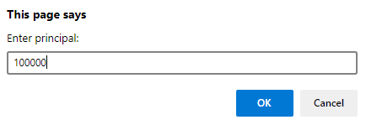

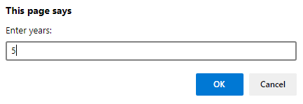

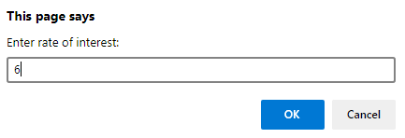



1. Write a JavaScript program that accepts two points and determines the distance between them. Use input popup box to get the input and display the calculated value using alert popup box. The formula is $Distance= \sqrt{{\left(x2-x1\right)}^{2}+{\left(y2-y1\right)}^{2}}$

<html>

  <body>

  </body>

  <script>

    x1 = prompt("Enter x1: ");

    y1 = prompt("Enter y1: ");

    x2 = prompt("Enter x2: ");

    y2 = prompt("Enter y2: ");

    distance = Math.sqrt(Math.pow(x2 - x1, 2) + Math.pow(y2 - y1,2));

    alert("Distance is " + distance.toString());

  </script>

</html>

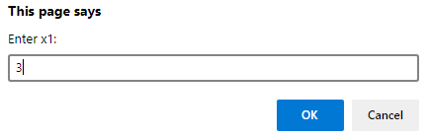 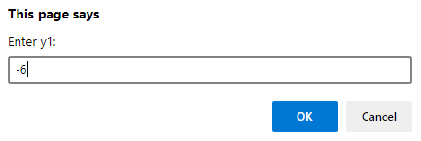

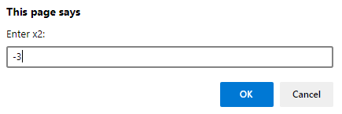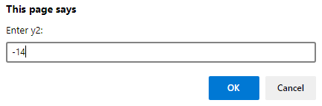

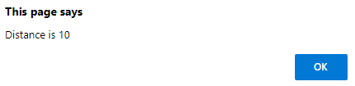

1. Write a JavaScript program to compute the Area of a Triangle when the three sides are given. The formula is $Area= \sqrt{s\left(s-a\right)\left(s-b\right)(s-c)}$, where $S= \frac{(a + b + c)}{2}$

<html>

  <body>

  </body>

  <script>

    const a = 3;

    const b = 4;

    const c = 5;

    const s = (a + b + c) / 2;

    const area = Math.sqrt(s * (s - a) *  (s - b) *  (s - c));

    console.log("Area is " , area);

  </script>

</html>



1. Write a JavaScript that asks the user to enter two numbers, obtains the two numbers from the user and outputs text that displays the sum, product, difference and quotient of the two numbers.

<html>

  <body>

  </body>

  <script>

    var num1 = parseInt(prompt("Enter number 1: "))

    var num2 = parseInt(prompt("Enter number 2: "))

    console.log(`Sum of ${num1} and ${num2} is ${num1+num2}`);

    console.log(`Difference of ${num1} and ${num2} is ${num1-num2}`);

    console.log(`Product of ${num1} and ${num2} is ${num1*num2}`);

    console.log(`Division of ${num1} and ${num2} is ${num1/num2}`);

  </script>

</html>

1. Write a JavaScript that takes three integers from the user and displays the sum, average, product, smallest and largest of the numbers in an alert dialog.

<html>

  <body>

  </body>

  <script>

    var num1 = parseInt(prompt("Enter number 1: "))

    var num2 = parseInt(prompt("Enter number 2: "))

    var num3 = parseInt(prompt("Enter number 3: "))

    alert(`Sum: ${num1+num2+num3}`);

    alert(`Average: ${(num1+num2+num3)/3}`);

    alert(`Product: ${num1*num2*num3}`);

    alert(`Smallest: ${Math.min(num1, num2, num3)}`);

    alert(`Largest: ${Math.max(num1, num2, num3)}`);

  </script>

</html>

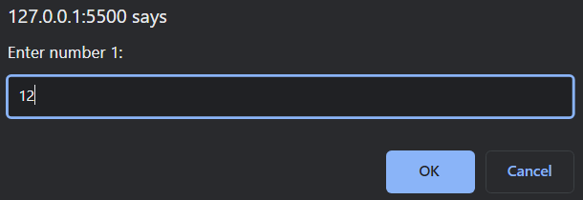 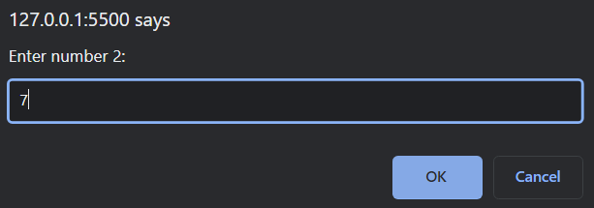

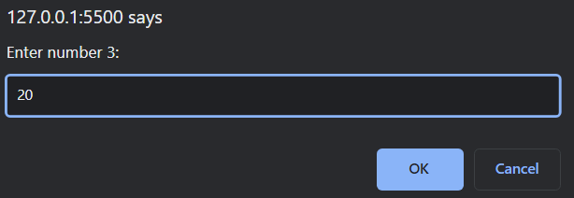 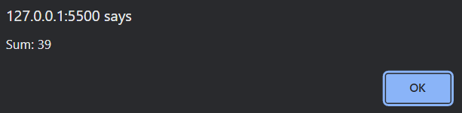

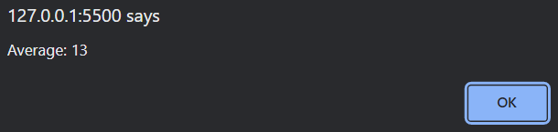 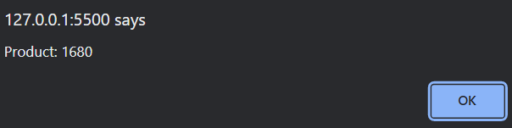

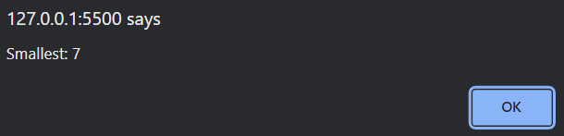 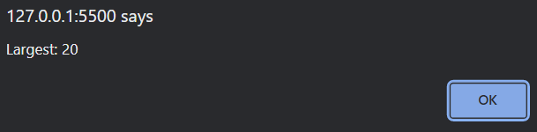

1. Write a JavaScript that inputs five numbers and determines and outputs HTML text that displays the number of negative numbers input, the number of positive numbers input and the number of zeros input.

<html>

  <body>

    <p id="output"></p>

  </body>

  <script>

    let num = [];

    let pos = 0, neg = 0, zero = 0;

    for(let i=1; i<=5; i++)

    {

      num[i-1] = parseInt(prompt(`Enter number ${i}: `));

      if(num[i-1] > 0)

      {

        pos += 1;

      }

      else if(num[i-1] < 0)

      {

        neg += 1;

      }

      else

      {

        zero += 1;

      }

    }

    console.log(num)

    document.getElementById("output").innerHTML = `Positive Numbers: ${pos}<br>Negative Numbers: ${neg}<br>Zero Numbers: ${zero}`;

  </script>

</html>

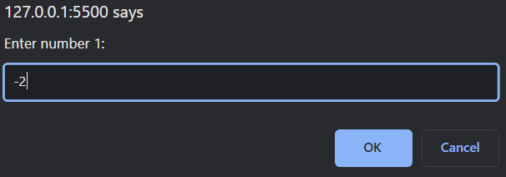 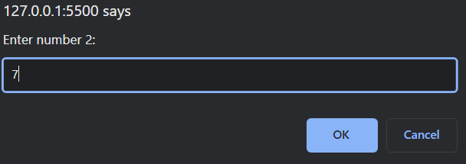

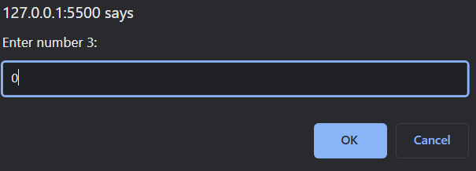 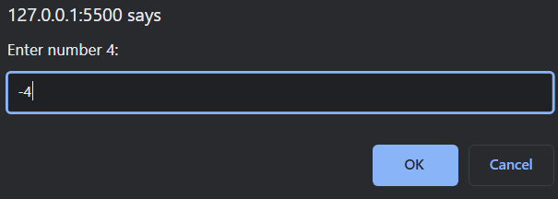

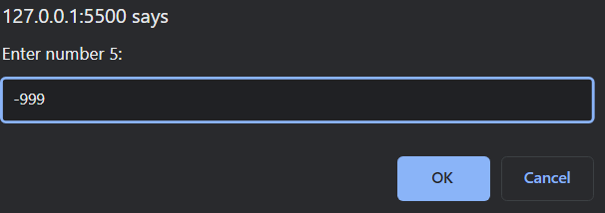 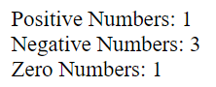

1. Write a JavaScript that reads in two integers and determines and outputs HTML text that displays whether the first is a multiple of the second.

<html>

  <body>

    <p id="output"></p>

  </body>

  <script>

    num1 = parseInt(prompt("Enter number 1: "));

    num2 = parseInt(prompt("Enter number 2: "));

    if(num1%num2==0)

    {

      document.getElementById("output").innerHTML = "First number is multiple of other";

    }

    else

    {

      document.getElementById("output").innerHTML = "First number is not a multiple of other";

    }

  </script>

</html>

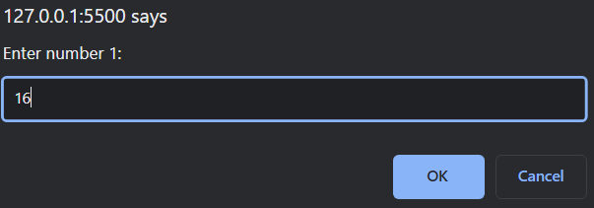 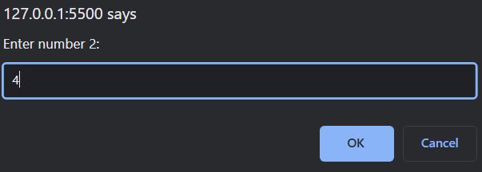



1. Write a script that calculates the squares and cubes of the numbers from 0 to 10 and outputs

HTML text that displays the resulting values in an HTML table format, as follows:

**number square cube**

0 0 0

1 1 1

2 4 8

3 9 27

4 16 64

5 25 125

6 36 216

7 49 343

8 64 512

9 81 729

10 100 1000

<html>

  <body>

  </body>

  <script>

      document.write('<table style="width: 30%; text-align: left;">');

      document.write('<th> number </th> <th> square </th> <th> cube </th>');

      for(var i=0; i<=10; i++)

        document.write("<tr style='color:red'><td>"+ i +"</td><td>"+ i**2 + "</td><td>"+ i**3 +"</td></tr>");

      document.write("</table>");

  </script>

</html>

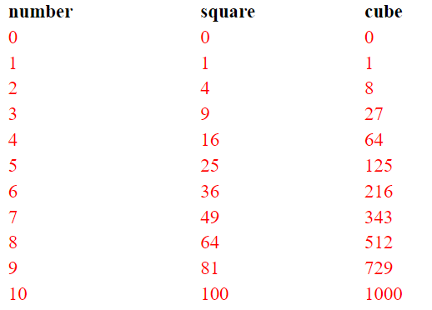

1. Write a JavaScript that reads a five-letter word from the user and produces all possible three letter words that can be derived from the letters of the five-letter word. For example, the three-letter words produced from the word “bathe” include the commonly used words “ate,” “bat,” “bet,” “tab,” “hat,” “the” and “tea.” Output the results in an alert popup box.

<html>

  <body>

  </body>

  <script>

      let word = prompt("Enter 5 letter word: ");

      let output = "";

      for(let i=0; i<5; i++)

      {

        for(let j=0; j<5; j++)

        {

          for(let k=0; k<5; k++)

          {

            if(i!=j && i!=k && j!=k)

              output = output + word[i] + word[j] + word[k] + " ";

            console.log(output);

          }

        }

      }

      alert(output);

  </script>

</html>

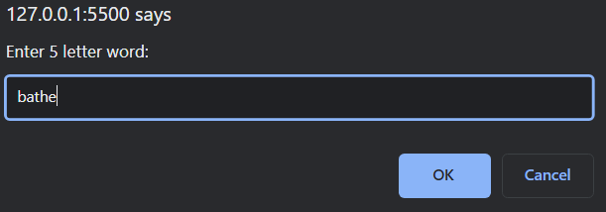01

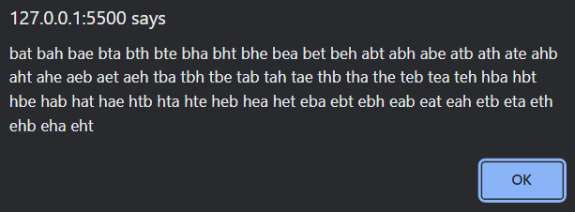

1. Write a JavaScript program to find the first occurrence and last occurrence of a string in a given string. Also find it after the specified position as well. Use string object. The web form as shown below:



<html>

  <script>

    var string = prompt("Enter string to search: ");

    document.write("<h1>The string to search is:<br>"+string+"</h1>");

    var substr = "";

    function getVal()

    {

      substr = document.getElementById("input").value;

    }

    function queryRes()

    {

      document.getElementById("res1").value = string.indexOf(substr);

      document.getElementById("res2").value = string.lastIndexOf(substr);

      document.getElementById("res3").value = string.indexOf(substr, 12);

      document.getElementById("res4").value = string.lastIndexOf(substr, 12);

    }

  </script>

  <body>

    <p>Enter substring to search for <input type="text" id="input" onblur="getVal()"> <button id="btn" onclick="queryRes()">Search</button></p>

    <p>First occurence located at index <input type="text" id="res1"></p>

    <p>Last occurence located at index <input type="text" id="res2"></p>

    <p>First occurence from index 12 is located at index <input type="text" id="res3"></p>

    <p>Last occurence from index 12 is located at index <input type="text" id="res4"></p>

  </body>

</html>

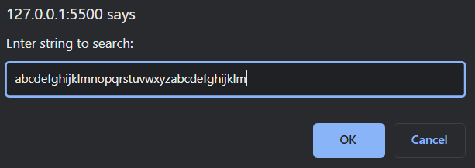

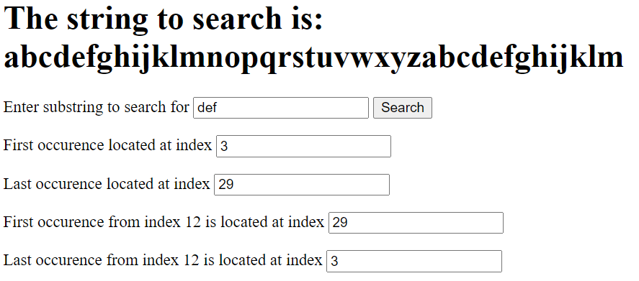

1. Dates are printed in several common formats. Write a JavaScript that reads a date from an HTML form and creates a **Date** object in which to store it. Then use the various methods of the **Date** object that convert Dates into strings to display the date in several formats.

<html>

  <body>

    <input type="date" id="date" onblur="mydate()">

    <p id="output"></p>

  </body>

  <script>

    function mydate()

    {

      const date = new Date(document.getElementById("date").value);

      document.getElementById("output").innerHTML = date + "<br>" + date.toUTCString() + "<br>" + date.toDateString() + "<br>" + date.toISOString();

    }

  </script>

</html>

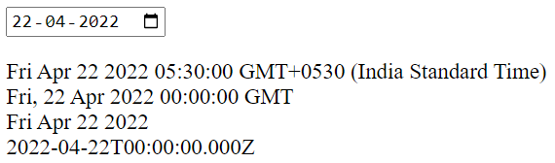

1. Write a JavaScript that tests as many of the Math library functions as you can. Exercise each of these functions by having your program display tables of return values for several argument values in an HTML textarea.

<html>

  <body>

    <textarea id="math"></textarea>

  </body>

  <script>

    document.getElementById("math").value = "round(): Math.round(2.7) "+Math.round(2.7)+"\nceil(): Math.ceil(2.7) "+Math.ceil(2.7)

    +"\nfloor(): Math.floor(2.7) "+Math.floor(2.7)+"\ntrunc(): Math.trunc(2.7) "+Math.trunc(2.7)+"\nsign(): Math.sign(-27) "+Math.sign(-27)

    +"\npow(): Math.pow(7, 2) "+Math.pow(7, 2)+"\nsqrt(): Math.sqrt(64)"+Math.sqrt(64)+"\nabs(): Math.abs(-2.7) "+Math.abs(-2.7)

    +"\nmin(): Math.min(2, -5, 4, 0) "+Math.min(2, -5, 4, 0)+"\nmax(): Math.max(2, -5, 4, 0) "+Math.max(2, -5, 4, 0)+"\nrandom(): "+Math.random()

    +"\nlog(): Math.log(1) "+Math.log(1)+"\nsin(): Math.sin(0) "+Math.sin(0);

  </script>

</html>

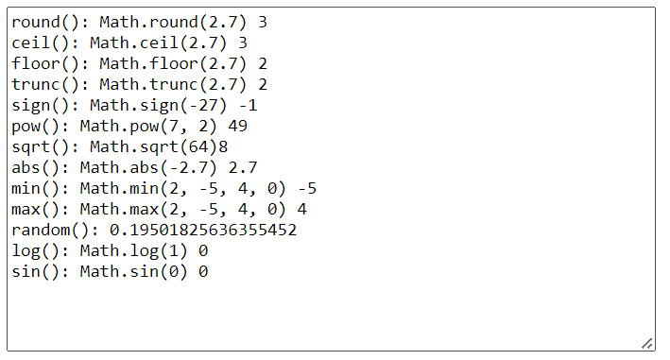

1. The process of finding the largest value (i.e., the maximum of a group of values) is used frequently in computer applications. For example, a program that determines the winner of a sales contest would input the number of units sold by each salesperson. The salesperson who sells the most units wins the contest. Write a JavaScript program that inputs a series of 10 real numbers as strings, determines the largest of the numbers and outputs a message that displays the largest number.

<html>

  <body>

    <p id="winner"></p>

  </body>

  <script>

    let sales = [];

    sales[0] = parseFloat(prompt("Enter sales unit of 10 persons: "));

    for (let i=1; i<9; i++)

    {

      sales[i] = parseFloat(prompt());

    }

    document.getElementById("winner").innerHTML = "WINNER of "+sales+" is "+Math.max(...sales);

  </script>

</html>



1. A mail-order house sells five different products whose retail prices are as follows: product 1, $2.98; product 2, $4.50; product 3, $9.98; product 4, $4.49; and product 5, $6.87. Write a JavaScript that reads a series of pairs of numbers as follows:

1. Product number

2. Quantity sold for one day

Your program should use a switch statement to determine each product's retail price and should calculate and output HTML that displays the total retail value of all the products sold last week. Use a ***prompt*** dialog to obtain the product number and quantity from the user. Use a sentinel-controlled loop to determine when the program should stop looping and display the final results. If the user inputs an invalid product number a proper ***alert*** window shall be displayed.

<html>

  <body>

    <p id="total">Hello</p>

  </body>

  <script>

    const prices = [2.98, 4.50, 9.98, 4.49, 6.87];

    let sum = 0;

    let ip = parseInt(prompt("Enter product number (999-stop): "));

    while(ip != 999)

    {

      quantity = parseInt(prompt("Enter quantity: "));

      switch(ip)

      {

        case 1:

          sum += quantity*prices[0];

          break;

        case 2:

          sum += quantity*prices[1];

          break;

        case 3:

          sum += quantity*prices[2];

          break;

        case 4:

          sum += quantity*prices[3];

          break;

        case 5:

          sum += quantity*prices[4];

          break;

        default:

          alert("Invalid product number!");

      }

      ip = parseInt(prompt("Enter product number (999-stop): "));

    }

    document.getElementById("total").innerHTML = "Total retail price is $ "+sum.toString();

  </script>

</html>

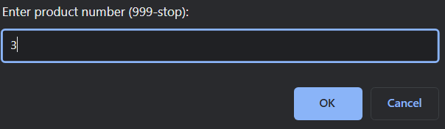 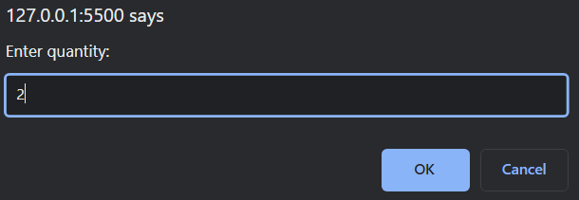



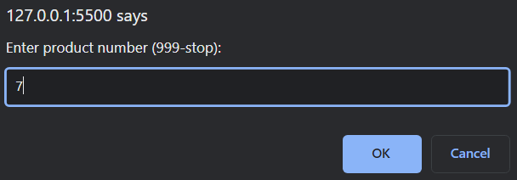 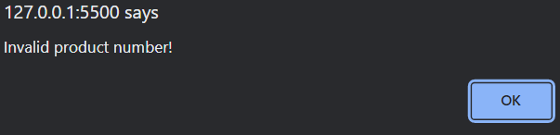

1. Develop a JavaScript program that will determine the gross pay for each of three employees.

The company pays “straight time” for the first 40 hours worked by each employee and pays “time and a half” for all hours worked in excess of 40 hours. You are given a list of the employees of the company, the number of hours each employee worked last week and the hourly rate of each employee. Your program should input this information for each employee, determine the employee’s gross pay and output HTML text that displays the employee's gross pay. Use ***prompt*** dialogs to input the data.

<html>

  <body>

    <p id="grosspay"></p>

  </body>

  <script>

    let name = [], hours = [], hourlyRate = [], salary = [];

    let output = "";

    for(let i=0; i<3; i++)

    {

      name[i] = prompt("Enter employee name: ");

      hours[i] = parseFloat(prompt("Enter hours worked: "));

      hourlyRate[i] = parseFloat(prompt("Enter hourly rate: "));

      if(hours[i]<=40)

      {

        salary[i] = hourlyRate[i]*hours[i];

      }

      else

      {

        salary[i] = hourlyRate[i]*40 + ((hours[i]%40)*hourlyRate[i]*1.5);

      }

      output += name[i]+" $"+salary[i]+"<br>";

    }

    document.getElementById("grosspay").innerHTML = output;

  </script>

</html>

Jersha – 172 – 4

Trisha – 30 – 2

Hema – 25 – 4

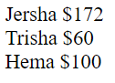

1. A company wants to transmit data over the telephone, but it is concerned that its phones may be tapped. All of its data is transmitted as four-digit integers. It has asked you to write a program that will encrypt its data so that the data may be transmitted more securely. Your script should read a four-digit integer entered by the user in a ***prompt*** dialog and encrypt it as follows: Replace each digit by (the sum of that digit plus 7) modulus 10. Then swap the first digit with the third, and swap the second digit with the fourth. Then output HTML text that displays the encrypted integer.

<html>

  <body>

    <p id="encrypt"></p>

  </body>

  <script>

    let num = parseInt(prompt("Enter 4 digit number to encrypt: "));

    let arr = [], index = 3;

    while(num > 0)

    {

      console.log(num);

      arr[index] = ((num%10)+7)%10;

      num = Math.trunc(num/10);

      index--;

    }

    let dummy = arr[0];

    arr[0] = arr[2];

    arr[2] = dummy;

    dummy = arr[1];

    arr[1] = arr[3];

    arr[3] = dummy;

    arr.map(String);

    document.getElementById("encrypt").innerHTML = "Encrypted Number: "+arr.join("");

  </script>

</html>

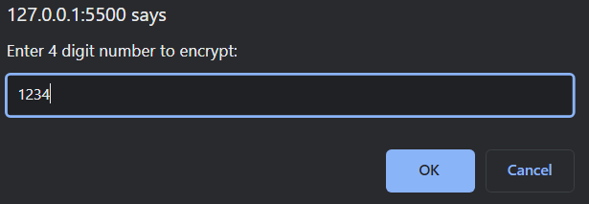



1. Write a script that finds the smallest of several non-negative integers. Assume that the first value read specifies the number of values to be input from the user.

<html>

  <body>

  </body>

  <script>

    let n = parseInt(prompt()), arr = [];

    for(let i=0; i<n; i++)

    {

      arr[i] = parseInt(prompt());

    }

    alert("Smallest integer: "+Math.min(...arr));

  </script>

</html>

Input: 4 –> 8 1 7 3

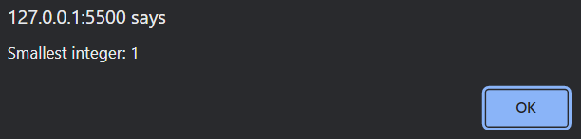

1. A palindrome is a number or a text phrase that reads the same backward and forward. For example, each of the following five-digit integers is a palindrome: 12321, 55555, 45554 and 11611. Write a script that reads in a five-digit integer and determines whether it is a palindrome. If the number is not five digits long, display an ***alert*** dialog indicating the problem to the user. Allow the user to enter a new value after dismissing the ***alert*** dialog.

<html>

  <body>

  </body>

  <script>

    let digit = prompt("Enter 5 digit integer: ");

    let len = digit.length;

    while(len != 5)

    {

      alert("Not a 5 digit number!");

      digit = prompt("Enter 5 digit integer: ");

      len = digit.length;

    }

    let flag = 1;

    for(let i=0; i<2; i++)

    {

      if(digit[i]!=digit[len-i-1])

      {

        alert("It is not a palindrome");

        flag = 0;

        break;

      }

    }

    if(flag)

    {

      alert("It is a palindrome");

    }

  </script>

</html>

